**Signature Verification:**

**Applications**:

1. Used in banks to verify signatures in Cheques.
2. Signature verification in official documents.



**Architecture of Model:**

**MODEL:** Multilayer Perceptron

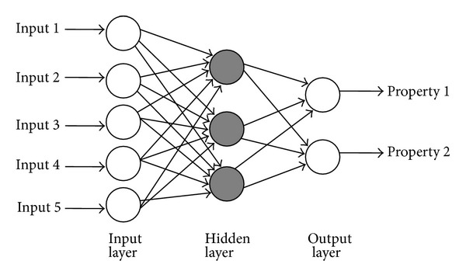

|  |
| --- |
|  |

**Network Parameters:**

1. **Number of neurons :**
   * + 1. I/P layer-7
       2. Hidden layer-10
       3. O/P layer-30
2. **Number of Classes:** 2 (Genuine &Forged)
3. **Learning Rate**-0.001
4. **Training Epochs**-1000
5. **Accuracy**- 88%

**6-Training Data-**

Genuine Signatures each of 10 PERSONS (50 Signatures)

1. **Testing Data-**

Provide person-id & path of the folder containing images of signature to be verified.

8.  **0/P**:

Program verify whether signature of person is genuine or forged.

**Pre-Processing Method:**

**1-Reading image using** matplotlib.image as mpimg

2**- Appling Fuzzification for Feature Extraction**:

Storing All the features in numerical form in csv files to sent as i/p to neural network.

Using Tensorflow inbuilt functions for 7 types of Feature Extraction

1-**Ratio-** Number of 1’s in Numpy matrix/ Total number of fields in matrix.

2**-Centroid**- Center of mass of the region.

3**-Skewness** 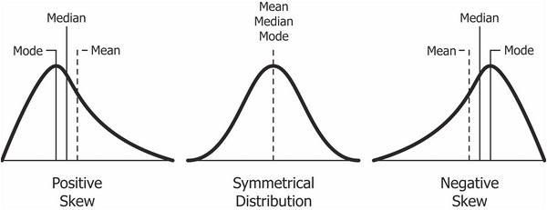 -x **Skewness** is asymmetry in a statistical distribution

4**-Kurtosis :** **It** is a measure of the "tailedness" of the probability distribution of a real-valued random variable. 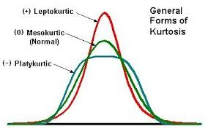

5- **Eccentricity** : Deviation of a curve or orbit from circularity.

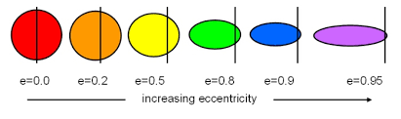

6**-Solidity**-Measures the thickness of strokes in signature.

Types of solidity

**Improvements that can be done to increase accuracy:**

1-Increasing dataset.

2- increasing hidden layers.